Golf Putting

1.
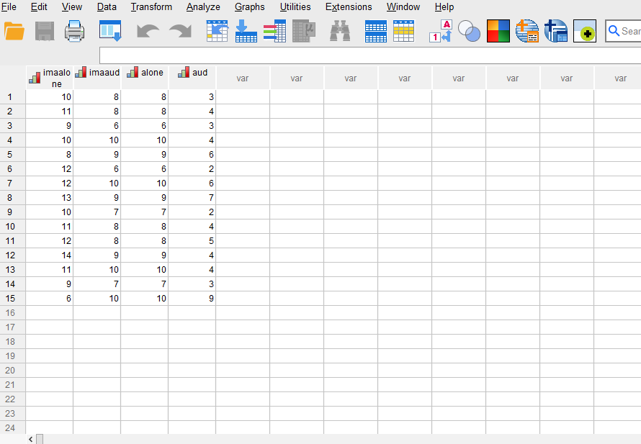
2.
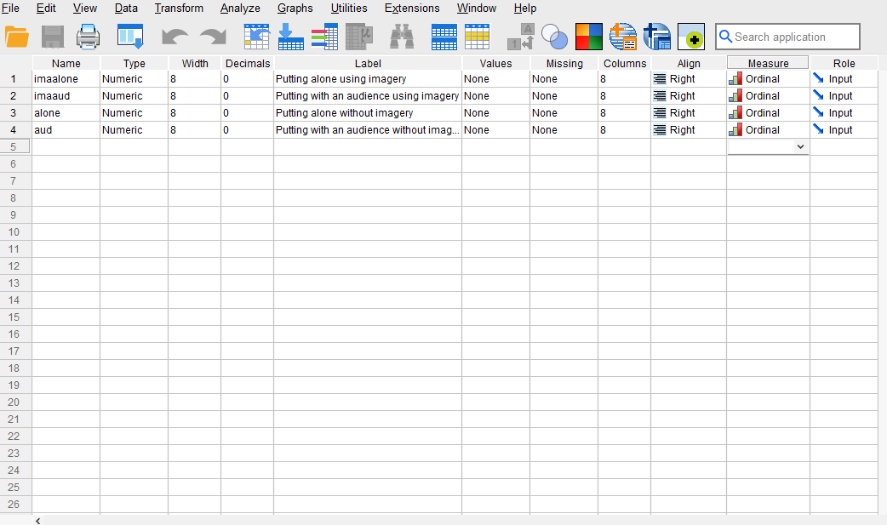

3. A different test is needed.
4. Dependent Variable = Golf putts, is ratio data.

5. Two-way analysis of variance within design is required.

6.
(a) F _{(1,14)} = 57.4, P<0.001 – main effect for psychtec;
F _{(1,14)} = 57.4, P<0.001 – main effect for environ;
F _{(1,14)} = , 7.1, P=0.019 – psychtec by environ interaction.
(b) Both the main effects and the interaction are significant.

(c) The main effect for psychological technique shows that more golf putts went in the hole when using imagery than when it was not used (9.4 vs. 6.4 putts respectively).
The main effect for environment shows that golf putting performance was more successful when the task was performed alone rather than in front of an audience (9.4 vs. 6.4 putts respectively).
The interaction shows that the reduction in putting performance with the introduction of an audience was smaller when imagery was used (10.5 to 8.3 putts) compared with the no imagery condition (8.3 to 4.4 putts).

(d) A significant main effect for psychological technique (F_{(1,14)} = 57.4, P<0.001) revealed that imagery appeared to have a positive effect on golf putting performance compared with when the technique was not used (9.4 vs. 6.4 putts respectively).
A significant main effect for environment (F_{(1,14)} = 57.4, P<0.001) revealed that putting in front of an audience had a negative effect on performance compared with putting alone (6.4 vs. 9.4 putts respectively).
A significant psychological technique by environment interaction (F_{(1,14)} = 7.1, P=0.019) showed that whilst an audience had a negative effect on putting performance when using imagery (10.5 and 8.3 putts respectively), it led to a larger reduction in performance compared with putting alone when imagery was not used (8.3 and 4.4 putts respectively).

Explore

Notes
Output Created |  | 21-NOV-2025 09:36:41
Comments
Input | Data | C:\Users\Dell\Downloads\2.Golf_Putting.sav
Input | Active Dataset | DataSet1
Input | Filter | <none>
Input | Weight | <none>
Input | Split File | <none>
Input | N of Rows in Working Data File | 15
Missing Value Handling | Definition of Missing | User-defined missing values for dependent variables are treated as missing.
Missing Value Handling | Cases Used | Statistics are based on cases with no missing values for any dependent variable or factor used.
Syntax |  | EXAMINE VARIABLES=imaalone imaaud alone aud  /PLOT BOXPLOT STEMLEAF HISTOGRAM NPPLOT  /COMPARE GROUPS  /STATISTICS DESCRIPTIVES  /CINTERVAL 95  /MISSING LISTWISE  /NOTOTAL.
Resources | Processor Time | 00:00:01.69
Resources | Elapsed Time | 00:00:01.34

Case Processing Summary
 | Cases
 | Valid |  | Missing |  | Total
 | N | Percent | N | Percent | N | Percent
Putting alone using imagery | 15 | 100.0% | 0 | 0.0% | 15 | 100.0%
Putting with an audience using imagery | 15 | 100.0% | 0 | 0.0% | 15 | 100.0%
Putting alone without imagery | 15 | 100.0% | 0 | 0.0% | 15 | 100.0%
Putting with an audience without imagery | 15 | 100.0% | 0 | 0.0% | 15 | 100.0%

Descriptives
 |  |  | Statistic | Std. Error
Putting alone using imagery | Mean |  | 10.53 | .524
Putting alone using imagery | 95% Confidence Interval for Mean | Lower Bound | 9.41
Putting alone using imagery | 95% Confidence Interval for Mean | Upper Bound | 11.66
Putting alone using imagery | 5% Trimmed Mean |  | 10.59
Putting alone using imagery | Median |  | 11.00
Putting alone using imagery | Variance |  | 4.124
Putting alone using imagery | Std. Deviation |  | 2.031
Putting alone using imagery | Minimum |  | 6
Putting alone using imagery | Maximum |  | 14
Putting alone using imagery | Range |  | 8
Putting alone using imagery | Interquartile Range |  | 3
Putting alone using imagery | Skewness |  | -.498 | .580
Putting alone using imagery | Kurtosis |  | .562 | 1.121
Putting with an audience using imagery | Mean |  | 8.33 | .361
Putting with an audience using imagery | 95% Confidence Interval for Mean | Lower Bound | 7.56
Putting with an audience using imagery | 95% Confidence Interval for Mean | Upper Bound | 9.11
Putting with an audience using imagery | 5% Trimmed Mean |  | 8.37
Putting with an audience using imagery | Median |  | 8.00
Putting with an audience using imagery | Variance |  | 1.952
Putting with an audience using imagery | Std. Deviation |  | 1.397
Putting with an audience using imagery | Minimum |  | 6
Putting with an audience using imagery | Maximum |  | 10
Putting with an audience using imagery | Range |  | 4
Putting with an audience using imagery | Interquartile Range |  | 3
Putting with an audience using imagery | Skewness |  | -.329 | .580
Putting with an audience using imagery | Kurtosis |  | -.970 | 1.121
Putting alone without imagery | Mean |  | 8.33 | .361
Putting alone without imagery | 95% Confidence Interval for Mean | Lower Bound | 7.56
Putting alone without imagery | 95% Confidence Interval for Mean | Upper Bound | 9.11
Putting alone without imagery | 5% Trimmed Mean |  | 8.37
Putting alone without imagery | Median |  | 8.00
Putting alone without imagery | Variance |  | 1.952
Putting alone without imagery | Std. Deviation |  | 1.397
Putting alone without imagery | Minimum |  | 6
Putting alone without imagery | Maximum |  | 10
Putting alone without imagery | Range |  | 4
Putting alone without imagery | Interquartile Range |  | 3
Putting alone without imagery | Skewness |  | -.329 | .580
Putting alone without imagery | Kurtosis |  | -.970 | 1.121
Putting with an audience without imagery | Mean |  | 4.40 | .496
Putting with an audience without imagery | 95% Confidence Interval for Mean | Lower Bound | 3.34
Putting with an audience without imagery | 95% Confidence Interval for Mean | Upper Bound | 5.46
Putting with an audience without imagery | 5% Trimmed Mean |  | 4.28
Putting with an audience without imagery | Median |  | 4.00
Putting with an audience without imagery | Variance |  | 3.686
Putting with an audience without imagery | Std. Deviation |  | 1.920
Putting with an audience without imagery | Minimum |  | 2
Putting with an audience without imagery | Maximum |  | 9
Putting with an audience without imagery | Range |  | 7
Putting with an audience without imagery | Interquartile Range |  | 3
Putting with an audience without imagery | Skewness |  | 1.015 | .580
Putting with an audience without imagery | Kurtosis |  | .961 | 1.121

Tests of Normality
 | Kolmogorov-Smirnovª |  |  | Shapiro-Wilk
 | Statistic | df | Sig. | Statistic | df | Sig.
Putting alone using imagery | .130 | 15 | .200* | .971 | 15 | .873
Putting with an audience using imagery | .150 | 15 | .200* | .900 | 15 | .097
Putting alone without imagery | .150 | 15 | .200* | .900 | 15 | .097
Putting with an audience without imagery | .249 | 15 | .013 | .907 | 15 | .122
*. This is a lower bound of the true significance.
a. Lilliefors Significance Correction

Putting alone using imagery

Putting alone using imagery Stem-and-Leaf Plot
Frequency Stem & Leaf
4.00 0 . 6899
11.00 1 . 00011122234
Stem width: 10
Each leaf: 1 case(s)

Putting with an audience using imagery

Putting with an audience using imagery Stem-and-Leaf Plot
Frequency Stem & Leaf
2.00 6 . 00
2.00 7 . 00
4.00 8 . 0000
3.00 9 . 000
4.00 10 . 0000
Stem width: 1
Each leaf: 1 case(s)

Putting alone without imagery

Putting alone without imagery Stem-and-Leaf Plot
Frequency Stem & Leaf
2.00 6 . 00
2.00 7 . 00
4.00 8 . 0000
3.00 9 . 000
4.00 10 . 0000
Stem width: 1
Each leaf: 1 case(s)

Putting with an audience without imagery

Putting with an audience without imagery Stem-and-Leaf Plot
Frequency Stem & Leaf
.00 0 .
5.00 0 . 22333
6.00 0 . 444445
3.00 0 . 667
1.00 0 . 9
Stem width: 10
Each leaf: 1 case(s)

General Linear Model

Notes
Output Created |  | 21-NOV-2025 09:56:20
Comments
Input | Data | C:\Users\Dell\Downloads\2.Golf_Putting.sav
Input | Active Dataset | DataSet1
Input | Filter | <none>
Input | Weight | <none>
Input | Split File | <none>
Input | N of Rows in Working Data File | 15
Missing Value Handling | Definition of Missing | User-defined missing values are treated as missing.
Missing Value Handling | Cases Used | Statistics are based on all cases with valid data for all variables in the model.
Syntax |  | GLM imaalone imaaud alone aud  /WSFACTOR=psychtec 2 Polynomial environ 2 Polynomial  /METHOD=SSTYPE(3)  /PLOT=PROFILE(psychtec*environ environ*psychtec) TYPE=LINE ERRORBAR=NO MEANREFERENCE=NO YAXIS=AUTO  /EMMEANS=TABLES(psychtec) COMPARE ADJ(LSD)  /EMMEANS=TABLES(environ) COMPARE ADJ(LSD)  /EMMEANS=TABLES(psychtec*environ) COMPARE(psychtec) ADJ(LSD)  /EMMEANS=TABLES(psychtec*environ) COMPARE(environ) ADJ(LSD)  /PRINT=HOMOGENEITY  /CRITERIA=ALPHA(.05)  /WSDESIGN=psychtec environ psychtec*environ.
Resources | Processor Time | 00:00:00.22
Resources | Elapsed Time | 00:00:00.24

Warnings
The HOMOGENEITY specification in the PRINT subcommand will be ignored because there are no between-subjects factors.

Within-Subjects Factors
Measure: MEASURE_1
psychtec | environ | Dependent Variable
1 | 1 | imaalone
1 | 2 | imaaud
2 | 1 | alone
2 | 2 | aud

Multivariate Testsª
Effect |  | Value | F | Hypothesis df | Error df | Sig.
psychtec | Pillai's Trace | .804 | 57.355^{b} | 1.000 | 14.000 | <.001
psychtec | Wilks' Lambda | .196 | 57.355^{b} | 1.000 | 14.000 | <.001
psychtec | Hotelling's Trace | 4.097 | 57.355^{b} | 1.000 | 14.000 | <.001
psychtec | Roy's Largest Root | 4.097 | 57.355^{b} | 1.000 | 14.000 | <.001
environ | Pillai's Trace | .804 | 57.355^{b} | 1.000 | 14.000 | <.001
environ | Wilks' Lambda | .196 | 57.355^{b} | 1.000 | 14.000 | <.001
environ | Hotelling's Trace | 4.097 | 57.355^{b} | 1.000 | 14.000 | <.001
environ | Roy's Largest Root | 4.097 | 57.355^{b} | 1.000 | 14.000 | <.001
psychtec * environ | Pillai's Trace | .336 | 7.094^{b} | 1.000 | 14.000 | .019
psychtec * environ | Wilks' Lambda | .664 | 7.094^{b} | 1.000 | 14.000 | .019
psychtec * environ | Hotelling's Trace | .507 | 7.094^{b} | 1.000 | 14.000 | .019
psychtec * environ | Roy's Largest Root | .507 | 7.094^{b} | 1.000 | 14.000 | .019
a. Design: Intercept
Within Subjects Design: psychtec + environ + psychtec * environ
b. Exact statistic

Mauchly's Test of Sphericityª
Measure: MEASURE_1
Within Subjects Effect | Mauchly's W | Approx. Chi-Square | df | Sig. | Epsilon^{b}
 |  |  |  |  | Greenhouse-Geisser
psychtec | 1.000 | .000 | 0 | . | 1.000
environ | 1.000 | .000 | 0 | . | 1.000
psychtec * environ | 1.000 | .000 | 0 | . | 1.000

Mauchly's Test of Sphericityª
Measure: MEASURE_1
Within Subjects Effect | Epsilon
Within Subjects Effect | Huynh-Feldt | Lower-bound
psychtec | 1.000 | 1.000
environ | 1.000 | 1.000
psychtec * environ | 1.000 | 1.000

Tests the null hypothesis that the error covariance matrix of the orthonormalized transformed dependent variables is proportional to an identity matrix.ª
a. Design: Intercept
Within Subjects Design: psychtec + environ + psychtec * environ
b. May be used to adjust the degrees of freedom for the averaged tests of significance. Corrected tests are displayed in the Tests of Within-Subjects Effects table.

Tests of Within-Subjects Effects
Measure: MEASURE_1
Source |  | Type III Sum of Squares | df | Mean Square | F
psychtec | Sphericity Assumed | 141.067 | 1 | 141.067 | 57.355
psychtec | Greenhouse-Geisser | 141.067 | 1.000 | 141.067 | 57.355
psychtec | Huynh-Feldt | 141.067 | 1.000 | 141.067 | 57.355
psychtec | Lower-bound | 141.067 | 1.000 | 141.067 | 57.355
Error(psychtec) | Sphericity Assumed | 34.433 | 14 | 2.460
Error(psychtec) | Greenhouse-Geisser | 34.433 | 14.000 | 2.460
Error(psychtec) | Huynh-Feldt | 34.433 | 14.000 | 2.460
Error(psychtec) | Lower-bound | 34.433 | 14.000 | 2.460
environ | Sphericity Assumed | 141.067 | 1 | 141.067 | 57.355
environ | Greenhouse-Geisser | 141.067 | 1.000 | 141.067 | 57.355
environ | Huynh-Feldt | 141.067 | 1.000 | 141.067 | 57.355
environ | Lower-bound | 141.067 | 1.000 | 141.067 | 57.355
Error(environ) | Sphericity Assumed | 34.433 | 14 | 2.460
Error(environ) | Greenhouse-Geisser | 34.433 | 14.000 | 2.460
Error(environ) | Huynh-Feldt | 34.433 | 14.000 | 2.460
Error(environ) | Lower-bound | 34.433 | 14.000 | 2.460
psychtec * environ | Sphericity Assumed | 11.267 | 1 | 11.267 | 7.094
psychtec * environ | Greenhouse-Geisser | 11.267 | 1.000 | 11.267 | 7.094
psychtec * environ | Huynh-Feldt | 11.267 | 1.000 | 11.267 | 7.094
psychtec * environ | Lower-bound | 11.267 | 1.000 | 11.267 | 7.094
Error(psychtec*environ) | Sphericity Assumed | 22.233 | 14 | 1.588
Error(psychtec*environ) | Greenhouse-Geisser | 22.233 | 14.000 | 1.588
Error(psychtec*environ) | Huynh-Feldt | 22.233 | 14.000 | 1.588
Error(psychtec*environ) | Lower-bound | 22.233 | 14.000 | 1.588

Tests of Within-Subjects Effects
Measure: MEASURE_1
Source |  | Sig.
psychtec | Sphericity Assumed | <.001
psychtec | Greenhouse-Geisser | <.001
psychtec | Huynh-Feldt | <.001
psychtec | Lower-bound | <.001
Error(psychtec) | Sphericity Assumed
Error(psychtec) | Greenhouse-Geisser
Error(psychtec) | Huynh-Feldt
Error(psychtec) | Lower-bound
environ | Sphericity Assumed | <.001
environ | Greenhouse-Geisser | <.001
environ | Huynh-Feldt | <.001
environ | Lower-bound | <.001
Error(environ) | Sphericity Assumed
Error(environ) | Greenhouse-Geisser
Error(environ) | Huynh-Feldt
Error(environ) | Lower-bound
psychtec * environ | Sphericity Assumed | .019
psychtec * environ | Greenhouse-Geisser | .019
psychtec * environ | Huynh-Feldt | .019
psychtec * environ | Lower-bound | .019
Error(psychtec*environ) | Sphericity Assumed
Error(psychtec*environ) | Greenhouse-Geisser
Error(psychtec*environ) | Huynh-Feldt
Error(psychtec*environ) | Lower-bound

Tests of Within-Subjects Contrasts
Measure: MEASURE_1
Source | psychtec | environ | Type III Sum of Squares | df | Mean Square | F
psychtec | Linear |  | 141.067 | 1 | 141.067 | 57.355
Error(psychtec) | Linear |  | 34.433 | 14 | 2.460
environ |  | Linear | 141.067 | 1 | 141.067 | 57.355
Error(environ) |  | Linear | 34.433 | 14 | 2.460
psychtec * environ | Linear | Linear | 11.267 | 1 | 11.267 | 7.094
Error(psychtec*environ) | Linear | Linear | 22.233 | 14 | 1.588

Tests of Within-Subjects Contrasts
Measure: MEASURE_1
Source | psychtec | environ | Sig.
psychtec | Linear |  | <.001
Error(psychtec) | Linear
environ |  | Linear | <.001
Error(environ) |  | Linear
psychtec * environ | Linear | Linear | .019
Error(psychtec*environ) | Linear | Linear

Tests of Between-Subjects Effects
Measure: MEASURE_1
Transformed Variable: Average
Source | Type III Sum of Squares | df | Mean Square | F | Sig.
Intercept | 3744.600 | 1 | 3744.600 | 719.128 | <.001
Error | 72.900 | 14 | 5.207

Estimated Marginal Means

1. psychtec

Estimates
Measure: MEASURE_1
psychtec | Mean | Std. Error | 95% Confidence Interval
psychtec | Mean | Std. Error | Lower Bound | Upper Bound
1 | 9.433 | .316 | 8.756 | 10.110
2 | 6.367 | .395 | 5.520 | 7.213

Pairwise Comparisons
Measure: MEASURE_1
(I) psychtec | (J) psychtec | Mean Difference (I-J) | Std. Error | Sig.^{b} | 95% Confidence Interval for Difference^{b}
 |  |  |  |  | Lower Bound | Upper Bound
1 | 2 | 3.067* | .405 | <.001 | 2.198 | 3.935
2 | 1 | -3.067* | .405 | <.001 | -3.935 | -2.198
Based on estimated marginal means
*. The mean difference is significant at the .05 level.
b. Adjustment for multiple comparisons: Least Significant Difference (equivalent to no adjustments).

Multivariate Tests
 | Value | F | Hypothesis df | Error df | Sig.
Pillai's trace | .804 | 57.355ª | 1.000 | 14.000 | <.001
Wilks' lambda | .196 | 57.355ª | 1.000 | 14.000 | <.001
Hotelling's trace | 4.097 | 57.355ª | 1.000 | 14.000 | <.001
Roy's largest root | 4.097 | 57.355ª | 1.000 | 14.000 | <.001
Each F tests the multivariate effect of psychtec. These tests are based on the linearly independent pairwise comparisons among the estimated marginal means.
a. Exact statistic

2. environ

Estimates
Measure: MEASURE_1
environ | Mean | Std. Error | 95% Confidence Interval
environ | Mean | Std. Error | Lower Bound | Upper Bound
1 | 9.433 | .316 | 8.756 | 10.110
2 | 6.367 | .395 | 5.520 | 7.213

Pairwise Comparisons
Measure: MEASURE_1
(I) environ | (J) environ | Mean Difference (I-J) | Std. Error | Sig.^{b} | 95% Confidence Interval for Difference^{b}
 |  |  |  |  | Lower Bound | Upper Bound
1 | 2 | 3.067* | .405 | <.001 | 2.198 | 3.935
2 | 1 | -3.067* | .405 | <.001 | -3.935 | -2.198
Based on estimated marginal means
*. The mean difference is significant at the .05 level.
b. Adjustment for multiple comparisons: Least Significant Difference (equivalent to no adjustments).

Multivariate Tests
 | Value | F | Hypothesis df | Error df | Sig.
Pillai's trace | .804 | 57.355ª | 1.000 | 14.000 | <.001
Wilks' lambda | .196 | 57.355ª | 1.000 | 14.000 | <.001
Hotelling's trace | 4.097 | 57.355ª | 1.000 | 14.000 | <.001
Roy's largest root | 4.097 | 57.355ª | 1.000 | 14.000 | <.001
Each F tests the multivariate effect of environ. These tests are based on the linearly independent pairwise comparisons among the estimated marginal means.
a. Exact statistic

3. psychtec * environ

Estimates
Measure: MEASURE_1
psychtec | environ | Mean | Std. Error | 95% Confidence Interval
 |  |  |  | Lower Bound | Upper Bound
1 | 1 | 10.533 | .524 | 9.409 | 11.658
1 | 2 | 8.333 | .361 | 7.560 | 9.107
2 | 1 | 8.333 | .361 | 7.560 | 9.107
2 | 2 | 4.400 | .496 | 3.337 | 5.463

Pairwise Comparisons
Measure: MEASURE_1
environ | (I) psychtec | (J) psychtec | Mean Difference (I-J) | Std. Error | Sig.^{b} | 95% Confidence Interval for Difference^{b}
 |  |  |  |  |  | Lower Bound
1 | 1 | 2 | 2.200* | .641 | .004 | .824
1 | 2 | 1 | -2.200* | .641 | .004 | -3.576
2 | 1 | 2 | 3.933* | .358 | <.001 | 3.165
2 | 2 | 1 | -3.933* | .358 | <.001 | -4.701

Pairwise Comparisons
Measure: MEASURE_1
environ | (I) psychtec | (J) psychtec | 95% Confidence Interval for Difference
environ | (I) psychtec | (J) psychtec | Upper Bound
1 | 1 | 2 | 3.576
1 | 2 | 1 | -.824
2 | 1 | 2 | 4.701
2 | 2 | 1 | -3.165

Based on estimated marginal means
*. The mean difference is significant at the .05 level.
b. Adjustment for multiple comparisons: Least Significant Difference (equivalent to no adjustments).

Multivariate Tests
environ |  | Value | F | Hypothesis df | Error df | Sig.
1 | Pillai's trace | .457 | 11.764ª | 1.000 | 14.000 | .004
1 | Wilks' lambda | .543 | 11.764ª | 1.000 | 14.000 | .004
1 | Hotelling's trace | .840 | 11.764ª | 1.000 | 14.000 | .004
1 | Roy's largest root | .840 | 11.764ª | 1.000 | 14.000 | .004
2 | Pillai's trace | .896 | 120.629ª | 1.000 | 14.000 | <.001
2 | Wilks' lambda | .104 | 120.629ª | 1.000 | 14.000 | <.001
2 | Hotelling's trace | 8.616 | 120.629ª | 1.000 | 14.000 | <.001
2 | Roy's largest root | 8.616 | 120.629ª | 1.000 | 14.000 | <.001
Each F tests the multivariate simple effects of psychtec within each level combination of the other effects shown. These tests are based on the linearly independent pairwise comparisons among the estimated marginal means.
a. Exact statistic

4. psychtec * environ

Estimates
Measure: MEASURE_1
psychtec | environ | Mean | Std. Error | 95% Confidence Interval
 |  |  |  | Lower Bound | Upper Bound
1 | 1 | 10.533 | .524 | 9.409 | 11.658
1 | 2 | 8.333 | .361 | 7.560 | 9.107
2 | 1 | 8.333 | .361 | 7.560 | 9.107
2 | 2 | 4.400 | .496 | 3.337 | 5.463

Pairwise Comparisons
Measure: MEASURE_1
psychtec | (I) environ | (J) environ | Mean Difference (I-J) | Std. Error | Sig.^{b} | 95% Confidence Interval for Difference^{b}
 |  |  |  |  |  | Lower Bound
1 | 1 | 2 | 2.200* | .641 | .004 | .824
1 | 2 | 1 | -2.200* | .641 | .004 | -3.576
2 | 1 | 2 | 3.933* | .358 | <.001 | 3.165
2 | 2 | 1 | -3.933* | .358 | <.001 | -4.701

Pairwise Comparisons
Measure: MEASURE_1
psychtec | (I) environ | (J) environ | 95% Confidence Interval for Difference
psychtec | (I) environ | (J) environ | Upper Bound
1 | 1 | 2 | 3.576
1 | 2 | 1 | -.824
2 | 1 | 2 | 4.701
2 | 2 | 1 | -3.165

Based on estimated marginal means
*. The mean difference is significant at the .05 level.
b. Adjustment for multiple comparisons: Least Significant Difference (equivalent to no adjustments).

Multivariate Tests
psychtec |  | Value | F | Hypothesis df | Error df | Sig.
1 | Pillai's trace | .457 | 11.764ª | 1.000 | 14.000 | .004
1 | Wilks' lambda | .543 | 11.764ª | 1.000 | 14.000 | .004
1 | Hotelling's trace | .840 | 11.764ª | 1.000 | 14.000 | .004
1 | Roy's largest root | .840 | 11.764ª | 1.000 | 14.000 | .004
2 | Pillai's trace | .896 | 120.629ª | 1.000 | 14.000 | <.001
2 | Wilks' lambda | .104 | 120.629ª | 1.000 | 14.000 | <.001
2 | Hotelling's trace | 8.616 | 120.629ª | 1.000 | 14.000 | <.001
2 | Roy's largest root | 8.616 | 120.629ª | 1.000 | 14.000 | <.001
Each F tests the multivariate simple effects of environ within each level combination of the other effects shown. These tests are based on the linearly independent pairwise comparisons among the estimated marginal means.
a. Exact statistic

Profile Plots

